**Software Requirement Specification**

**Group 4 - Event Management Website**

**Introduction:**

**- Purpose:**

An event management website designed using HTML serves as a centralized platform for organizing, promoting, and attending events. Users can easily browse upcoming events, register for their preferred ones, and purchase tickets seamlessly. For event organizers, the website provides tools to create event listings, manage registrations, and communicate important information to attendees. With features for social interaction, users can engage with the community, share events, and provide feedback. Through effective customization options, the website ensures a personalized experience for each user, enhancing their overall event discovery and participation journey.

**- Document conventions:**

Documenting conventions for an event management website using HTML involves a few important steps. First, we keep the HTML structure clear and consistent, using elements like <html>, <head>, and <body>, along with metadata for search engines. Comments <!-- --> are helpful for explaining complex code parts. Using semantic HTML elements helps with accessibility and search engine optimization (SEO). We use IDs and classes to group similar elements, and document their purpose clearly. CSS styles and JavaScript functionalities should be well-documented too, explaining how they affect the website's appearance and behavior. We also consider accessibility and test across different browsers and devices for a consistent user experience. Lastly, we document responsive design principles to ensure the website looks good on all screen sizes.

**Project Scope**

The user authentication feature ensures that only authorized individuals can access the system by securely logging in with a username and password. Users can create tasks, assign them to team members, and set deadlines, which helps in better planning and prioritization. They can monitor project progress in real-time, track completed tasks, and receive notifications about upcoming deadlines or changes in task statuses. Collaboration among team members is facilitated through sharing task descriptions and discussing project-related topics, fostering effective communication and teamwork. Users can customize the workflow according to their requirements, and the system generates reports and analytics to provide insights into project performance. Integration with other tools and applications, along with accessibility across multiple devices, ensures flexibility and convenience for users.

**Overall Description:**

**Product Persepective:**

Approaching the development of an event management website using HTML involves several key steps. Firstly, it's important to set clear goals, define what the website will do, and who it's for. Then, we need to gather the right people and tools to make it happen, like designers and programmers. Creating a timeline helps us stay on track and make sure everything gets done on time. We also need to think about what could go wrong and how to handle it. Regularly talking with everyone involved helps keep things running smoothly. Testing the website with real users helps make sure it's easy to use and works well. We'll also create guides and help resources so people know how to use it. Once everything's ready, we'll launch the website and keep it running smoothly over time.

**Product Features:**

**Event Listings**: Display a comprehensive list of upcoming events, including details such as date, time, location, description, and ticket availability.

**Event Search and Filters**: Enable users to search for events based on criteria such as location, date, category, or keyword, with filtering options to refine results.

**User Registration and Authentication**: Allow users to register accounts securely, log in, and manage their profiles, including preferences and past event attendance history.

**Event Registration and Ticketing**: Provide users with the ability to register for events they're interested in attending, select ticket types, make payments securely, and receive confirmation emails or tickets.

**Event Creation and Management**: Offer event organizers tools to create and manage event listings, including options to set event details, ticket types, pricing, and capacity limits.

**Notification and Communication**: Implement functionality for sending notifications and updates to users regarding event registrations, changes, or cancellations via email or in-app notifications.

**Social Interaction**: Integrate social media sharing options to allow users to promote events on their networks, as well as features for community interaction such as comments, ratings, and reviews.

**Admin Dashboard**: Provide administrators with a centralized dashboard to manage users, events, payments, content, and overall website functionality.

**User Class and Characteristics:**

The event management website has three main user groups: event organizers, attendees, and administrators. Event organizers have special privileges to create, manage, and promote events. They can set details like dates, locations, and ticket options, and use tools to track event performance. Attendees are people who browse and join events. They can see event details, register, and pay for tickets securely. They also get confirmation emails and access event info like agendas and speakers. Administrators are in charge of the website. They manage user accounts, ensure site security, and monitor content to keep things running smoothly. All these groups work together to make sure the website works well and events run smoothly.

**Operating Environment:**

In the world of the event management website, different parts work together like a theater production backstage. Web servers act as the stage, showing the website to users. Database servers are like a storage room, keeping all the event and user info safe. Just like building sets, HTML, CSS, and JavaScript are used to create the website, while other languages like PHP or Python help it run smoothly. Content Delivery Networks are backups, making sure everyone can access the website quickly. Web browsers are the viewers, needing the website to look good and work well no matter which one they use. Web servers can be like different theater systems, running on Windows or Linux. Lastly, development tools are like crew tools, helping build and set up the website for its audience. Together, they make sure the event management website runs smoothly for everyone.

**Design Implementation and Constraints:**

When building the website, we first create a clear layout using headers, navigation bars, and sections to organize content neatly. Then, we make it look good on any screen by choosing colors, fonts, and spacing carefully. Adding interactive features like dropdown menus and form validation makes it easier to use. We also ensure everyone can access it by including keyboard navigation and clear content.

To keep everything running smoothly, we test the site on different browsers and make sure it loads quickly. It's essential that it works well on all devices, so we use responsive design techniques. Security is crucial, so we protect against hackers with encryption and validation. Lastly, we prepare for the future by ensuring the site can handle more users and content without any issues. With these steps, we create a website that's not only attractive but also safe, easy to use, and ready to grow.

**External interface requirements**

The event management website needs to be user-friendly and work seamlessly across various devices and software platforms. Its interface should be intuitive, making it easy for users to navigate and find the information they need about upcoming events. Whether accessed on a computer, phone, or tablet, the website should provide a consistent and enjoyable experience for all users. Additionally, it must ensure the security of user data during transactions and communications, using encryption protocols to protect sensitive information.

Furthermore, effective communication is key, with the website capable of sending notifications and updates via email or real-time messages to keep users informed about event registrations, changes, or cancellations. By meeting these requirements, the website can provide a smooth and reliable platform for users to discover, register for, and engage with events, enhancing their overall experience and satisfaction.

**User Interface Design:**

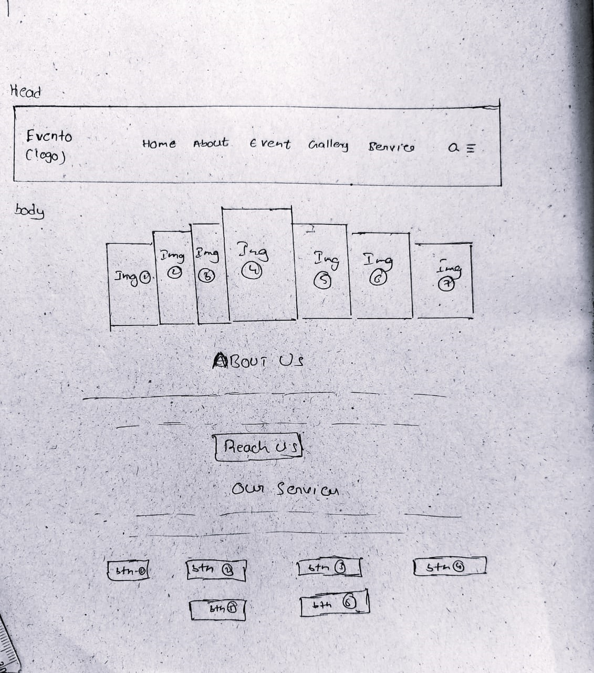

**Team Members:**

• AM.SC.U4CSE23134 – M.Kumar

• AM.SC.U4CSE23114 – CH.Lokesh

• AM.SC.U4CSE23127 – K.V.S.Shasank

• AM.SC.U4CSE23159 – M.Sujith

• AM.SC.U4CSE23173 – A.SreeVisakh